**红底白字为UI上暂时未有的**

**New USD Fund Menu in English / Chinese Language**

1. **Portfolio List Page 投资项目列表页**



|  |  |  |  |  |  |  |  |  |  |
| --- | --- | --- | --- | --- | --- | --- | --- | --- | --- |
| English | Portfolio Name (Eng) | Portfolio Name (Chi) | Company Name (Eng) | Company Name (Chi) | Project Manager | Portfolio Status | IDG On Board | Held By SPV | Operation |
| Chinese | **项目名称（英文）** | **项目名称（中文）** | **公司名称（英文）** | **公司名称（中文）** | **项目经理** | **项目状态** | **是否IDG董事** | **是否SPV代持** | **操作** |

1. **Portfolio Basic Information 项目基本信息**

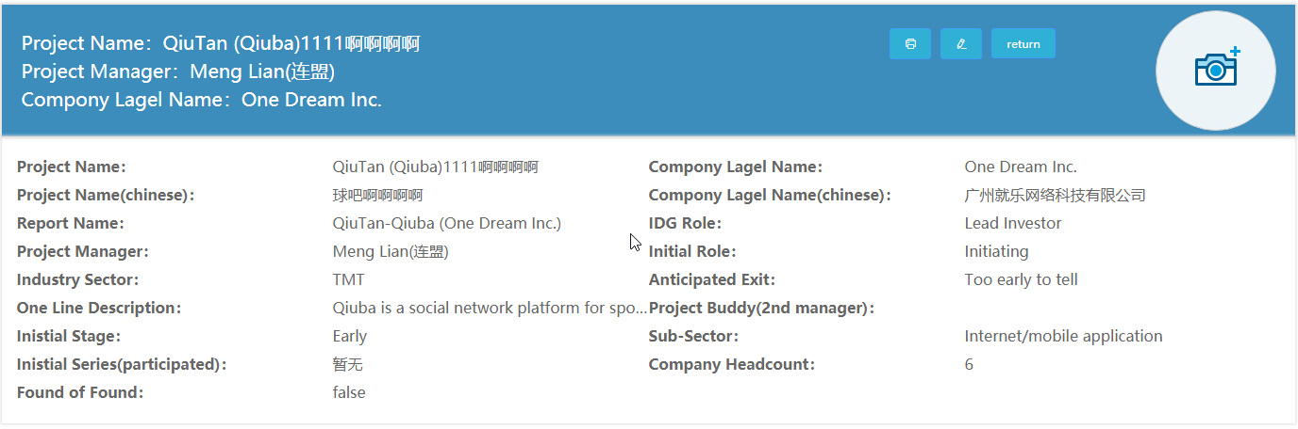

|  |  |  |  |  |  |  |  |  |  |  |  |  |  |
| --- | --- | --- | --- | --- | --- | --- | --- | --- | --- | --- | --- | --- | --- |
| English | Portfolio Name | Portfolio Name (Chinese) | Company Legal Name | Company Legal Name (Chinese) | Report Name | Project Manager | Project Buddy | IDG Role | Initial Stage | Initial Role | IDG Initial Series | Sector | Sub-Sector |
| Chinese | **项目名称** | **项目名称（中文）** | **公司法人名称** | **公司法人名称（中文）** | **报表用名称** | **项目经理** | **项目成员** | **IDG角色** | **初始阶段** | **初始角色** | **IDG初投轮次** | **行业** | **行业细分** |
|  |  |  |  |  |  |  |  |  |  |  |  |  |  |
| English | **Website** | **Logo** | **CEO** | **Headcount** | **Anticipated Exit** | **Fund Of Fund** | **One Line Description** **(Business Summary)** | **One Line Description (Chinese) (Business Summary)** | **Primary Business** **(Gary Table)** | **Product (Whitebook)** |  |  |  |
| Chinese | **网站** | **Logo** | **CEO** | **公司员工数** | **预期退出** | **基金项目** | **业务简介 (Business Summary)** | **业务简介（中文）(Business Summary)** | **主营业务(Gary Table)** | **产品 (Whitebook)** |  |  |  |

1. **Portfolio Legal Data 项目法务信息**



|  |  |  |  |  |  |  |  |  |  |
| --- | --- | --- | --- | --- | --- | --- | --- | --- | --- |
| English | Year Of Incorporation | Incorporated In | Company Register No. | Investment Structure Legal form | IDG Inhouse Counsel | IDG Boardseat Representative | Total Boardseat NO. | IDG Observer | Liquidation Preference |
|  |  |  |  |  |  |  |  |  |  |
| Chinese | **公司法人注册年份** | **公司法人注册国家** | **公司法人注册编号** | **法人投资结构** | **IDG法律顾问** | **IDG董事** | **全体董事人数** | **IDG观察员** | **清算优先权** |
|  |  |  |  |  |  |  |  |  |  |

1. **Portfolio Contact Information 项目联系信息**

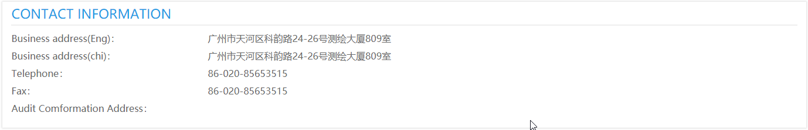

|  |  |  |  |  |  |
| --- | --- | --- | --- | --- | --- |
| English | Telephone | Fax | Business Address | Business Address (Chinese) | Audit Confirmation Address |
| Chinese | **电话** | **传真** | **公司地址** | **公司地址（中文）** | **审计确认函地址** |

1. **Portfolio IPO/Listing Record 项目上市发行记录**

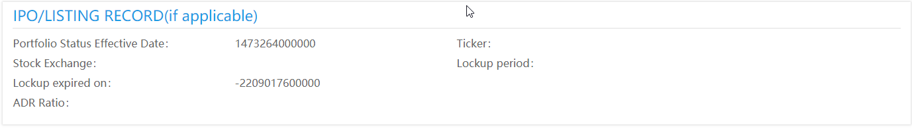

|  |  |  |  |  |  |  |  |  |
| --- | --- | --- | --- | --- | --- | --- | --- | --- |
|  |  |  |  | Only If Public Status 仅限于Public状态 | | | | |
| English | **Portfolio Status** | **Effective Date** | **Financial YTD** | **IPO Date** | **Stock Exchange** | **Stock Code** | **Lockup Expired Date** | **ADD Ratio** |
| Chinese | **项目状态** | **状态生效日期** | **财务本年截止日期** | **上市日期** | **上市交易所** | **股票代码** | **禁售期** | **大盘涨跌比** |